The Year of Consecrated Life

During a November meeting with 120 superior generals from all over the world, Pope Francis announced that the Year 2015 would be dedicated as the Year of Consecrated Life. During this meeting, Pope Francis emphasized the importance of the religious vocation and invited the church's religious sisters, brothers and priests to “wake up the world” with their testimony of faith, holiness and hope. Pope Francis thanked the religious for their witness to Jesus Christ. “Thank you for what you do and for your spirit of faith and your service. Thank you for your witness and also for the humiliations through which you have had to pass.”
This special Year dedicated to Consecrated Life will begin on Nov. 21, 2014 and will conclude one year later on the 50th anniversary of the promulgation of the Second Vatican Council decree “Perfectae Caritatis” on the renewal of religious life.
“In this year, we want to show the world with strength and joy the holiness and vitality that are present in consecrated life” says Cardinal Joao Braz de Aviz, prefect of the Congregation for Institutes of Consecrated Life and Societies of Apostolic Life.
Following the announcement to all the major superiors, Pope Francis wrote a letter to all consecrated people titled: “Rejoice.” This letter not only sets out the aims of the year, but calls each consecrated man and woman to renew their commitment to Jesus Christ, and to live out their religious vows and charisms with visible joy!
Cardinal João Braz De Aviz, Prefect of the Congregation for Institutes of Consecrated Life and Societies of Apostolic Life said: “We believe that the Second Vatican Council has been a breath of the Spirit not only for the whole Church but, perhaps especially, for the consecrated life. We are also convinced that in these 50 years consecrated life has undertaken a fruitful journey of renewal, not free, certainly, of difficulties and hardships in the commitment to follow what the Council asked of the consecrated: fidelity to the Lord, to the Church, to their own charism and to the people of today.”

According to Vatican statistics, there are nearly one million people living religious, consecrated life within the church. The Catholic faith is unique when compared to other Christian denominations because it invites people to live as monks, nuns, and priests, under vows of consecrated chastity, poverty, and obedience. No other Christian denomination asks such lifetime devotion.
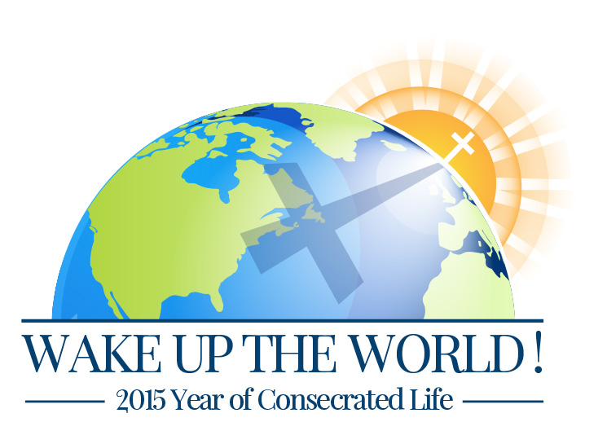
While this year is dedicated to consecrated life, Pope Francis in his inclusive way challenges all of us to live holy lives. He says: “I invite all Christians to renew their personal encounter with Jesus Christ, or at least to make the decision to let ourselves be found by Him, to seek Him every day without fail.”

