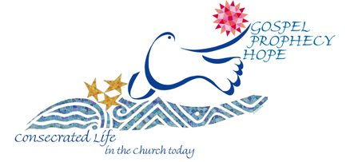
Consecrated Life is the “unceasing work of the Holy Spirit, who in every age shows forth the richness of the practice of the evangelical counsels through a multiplicity of charisms. In this way too He makes ever present in the Church and in the world, in time and space, the mystery of Christ” (Vita Consecrata- 5).
Pope Francis proclaimed 2015 the Year of Consecrated Life for renewal, remembrance, and hope. The special year dedicated to all men and women who live this vocation, opens on the first Sunday of Advent, Nov. 30.
Consecrated life is a gift given by Jesus Christ to a person who freely chooses to respond to this call. Jesus calls this individual to respond to His great love and invites them into a special relationship with Him. He invites that person to leave some aspects of the world (such as marriage and following secular goals) to put themselves at the service of His people.
Consecrated life is a vocation just as marriage and diocesan priesthood are. Both men and women can respond to this call to consecrate their lives to Christ as they enter into an intimate relationship with Him. These men and women give witness that Christ is ultimately who we are called to be united to. They live the truth that only Christ can satisfy the deepest longings in a person’s heart, and witness that this union provides a deeper joy than the secular world can give. In effect they are previewing the way we will relate to Christ in heaven.
Those in consecrated life generally join a religious order. There are hundreds of men and women’s religious communities founded by men and women throughout the centuries and founded to do a particular work for the Church. Consecrated life is most often shared and lived in a community which is united to live out their common mission together. Each religious community brings special gifts to the Church through their commitment and ministry and these special gifts are called the charism of the community.
Fr. Shawn McKnight speaks on the different forms of consecrated life and their particular callings.
http://link.brightcove.com/services/player/bcpid506929354001?bckey=AQ~~,AAAAdgye3dk~,p0Zv3iru3vLtuHJC18uO4sBMTKhhmskf&bclid=0&bctid=2047986066001

